Lab 5: Trees

Consider the examples on the next page. Analyze the structures of the trees and make the conclusion with regard to their properties.
Complete the following exercises, then enter your answers individually in “Unit 6A Quiz” on D2L Tests.
Note: Be careful using any external resources, they may not match the definitions we use in this class! Refer to Unit 6A slides for the correct terminologies.

Example | Binary Tree? | Balanced? | Proper? | Full? | Complete? | height | size
A
B
C
D
E
F
G
H
I
J
K
L

A  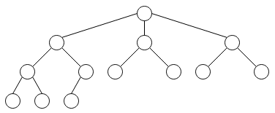 | B  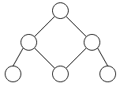
C   | D  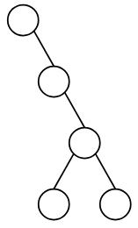
E  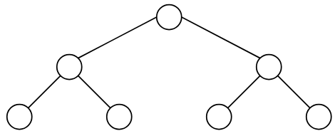 | F  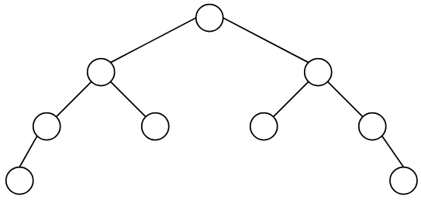
G  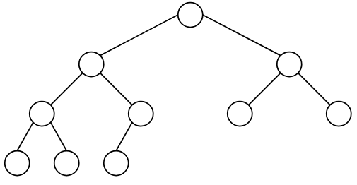 | H  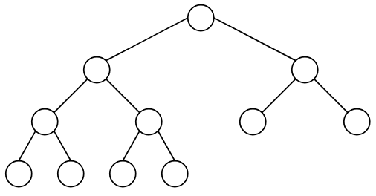
I  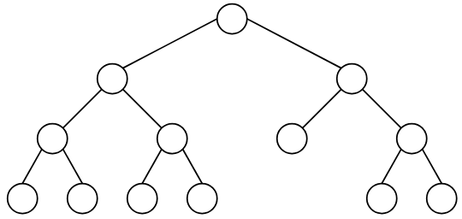 | J  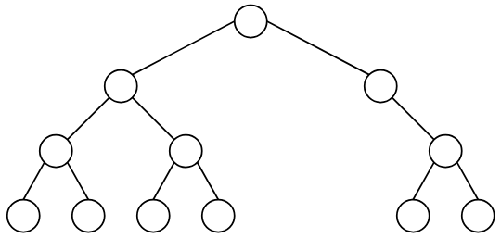
K  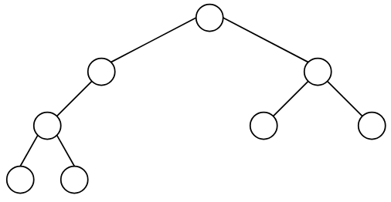 | L  